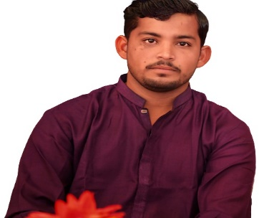

**Eshwar Kumar**

Malhi Para, Chelhar Taluka Mithi Distric Tharparkar

Contact: +923442724387 Email: [eshwarlal360@gmail.com](mailto:eshwarlal360@gmail.com)

**Objective**

* To obtain a position that challenges me and provides the opportunity to reach my full potential professionally and personally, and utilizing my abilities and experience to progress intellectually and technically and one in which practices collaborative leadership, integrity and honesty

**Personal Portfolio**

|  |  |
| --- | --- |
| * Father’s Name:  **Gordhan** * Religion: **Hindu** * Marital Status: **Single** | * CNIC Number: **44301-1740452-7** * Nationality: **Pakistani** * Date of Birth: **04 / june / 1996** |

**Qualification**

**Qualification / Degree Division / Position / Grade Institution**

**Inter (Pre-Medical) “2nd” Division** Govt. Boys Degree College Mithi

**Matriculation “A” Grade** Govt. R. R. High School Chelhar

|  |
| --- |
| **Excellent Communication Skills** |

**Languages**

* **Sindhi** (Mother Tongue)
* **Urdu** (Read, Write, Speak)
* **English** (Read, Write, Speak)

**Reference available on Demand**